**CRICPEDIA**

**GROUP D**

Queries:

Q1) Write a query to display teams details according to ranking in descending order.

A1) 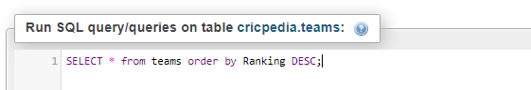

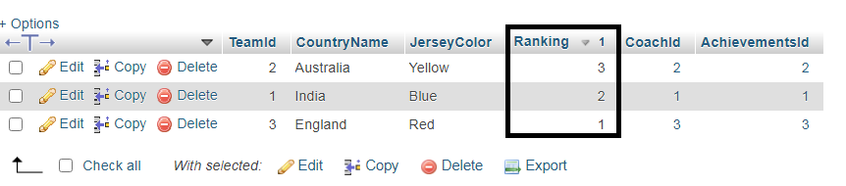

Q2) Write a query to find the max and min runs scored by David warner in whole tournament.

A2) 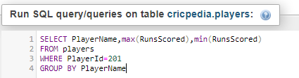

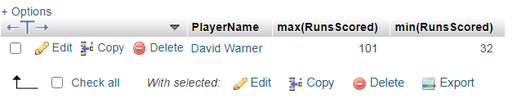

Q3) Write a query to display the record of Man of match in first match.

A3) 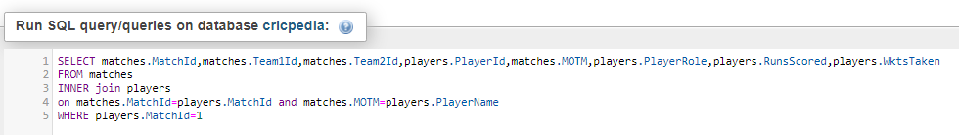

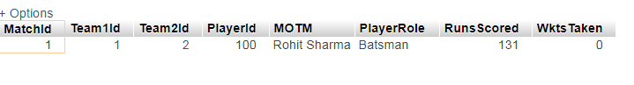

Q4) Write a query to display details of player with max. Runs scored and with max. Wkts taken in the tournament.

A4) 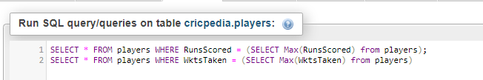

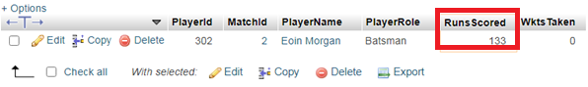

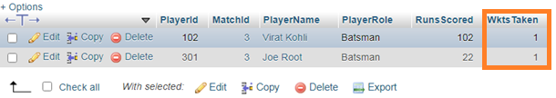

Q5) Write a query to check whether player record with bat avg in 50 to 60 exists.

A5) 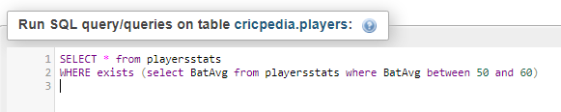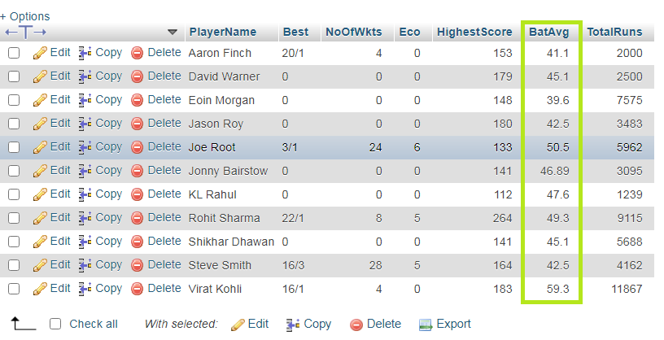

Q6) Write a query to display teams details with ICC cups >1 and T20Cups < 3.

A6) 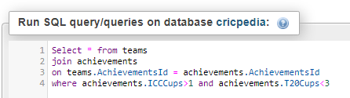

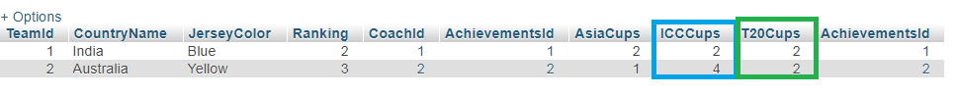

Q7) Write a query to display all details of Coach whose duration is >= 6 using “ANY” and “ALL” operator.

A7) 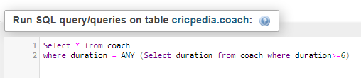

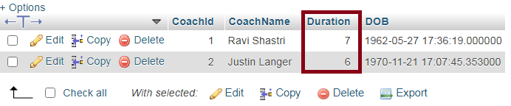

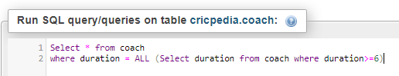

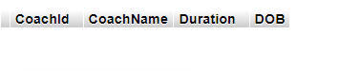

**THANK YOU**